Table of Contents
Table of Figures 1
(1) 2
A) use case diagram 2
Assumptions for The pawn Shop use case Diagram 3
B) Class Diagram 4
C) Sequans Diagram 6
(2) 12
Object 12
Classes 13
Abstraction 14
Inheritance 15
Encapsulation 16
Polymorphism 17
(4)User Manual for The Paws Shop Application 18
Introduction 18
Using the Application 19
Functionalities 22
Manager Functionalities 26
Error Handling and Troubleshooting 27
References 28

Table of Figures

Figure 1/Use case diagram 6
Figure 2/Class diagram 8
Figure 3/Login sequans diagram 10
Figure 4/Add petsupplie detail sequans diagram 11
Figure 5/View all sequans diagram 12
Figure 6/Search by category sequans diagram 13
Figure 7/Add new category sequans diagram 14
Figure 8/Sign up sequans diagram 15
Figure 9/oop concepts 16

(1)

use case diagram

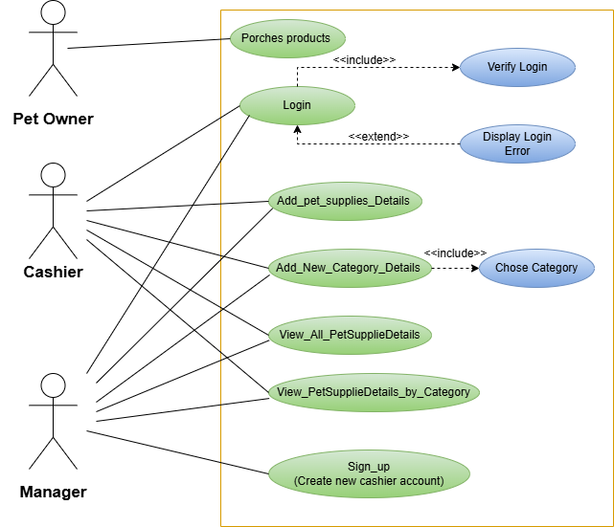
Figure 1/Use case diagram

Assumptions for The pawn Shop use case Diagram

- Only the manager can create new cashier accounts.
- Manager and Cashier must log in to access system functionalities. The login process include verification steps, with a login error displayed if credentials are included.
- Casher can add new pet supplies and organize them into categories, add new category but they can’t manage casher accounts.
- Pet owners can only browse and purchase products. They don’t have any control over inventory or user account.
- The system has set categories for pet supplies as toys, cages and collars. Cashiers must assign new products to existing categories and if a needed category is not available, they need to add new category through the proper process.
Primary Actors
- Casher
- Can add new pet supplies and categorize them.
- Can view all pet supplies and search based on categories.
- Manager
- Can perform all cashier functions
- Can add new cashier
Secondary Actors
- Pet owner
- Only can borrow and porches products.

Design Choices
Separate GUIs.
Managers and cashiered have dedicated GUIs tailored to their specific tasks, improving user experience.

B) Class Diagram
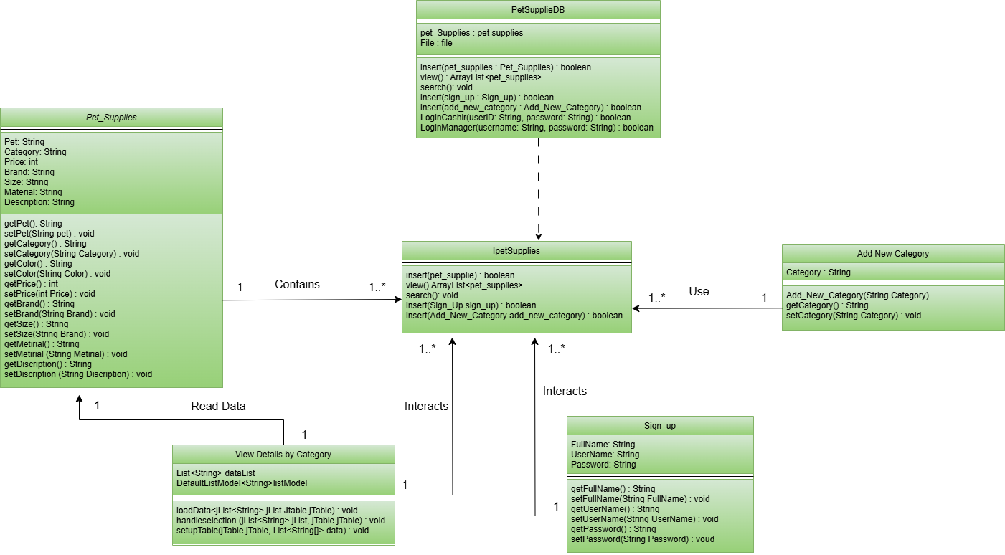

Figure 2/Class diagram

- Pet_Supplies, Add_new_Category and View_Details_By_Categorys.

- The pet_Supplies class contains the main details of each pet supply item, such as the pet type, category, color, price and brand.
- Add_Nwe_Category manages categories for pet supplies allowing users to add new categories and set specific attributes.
- View_Deatails_By_Category reads and display pet supplies by category, helping users to filter and view items based on specific categories.

- PetSupplieDB and IpetSupplies .

- The PetSupplieDB class implements the IpetSupplies which defines core methods like insert and view
- This allows PetSupplieDB to manage all interactions with pet supplies data including categories , sign up while adhering to the standard defined by the Ipetsupplies .

- Cashier and Manager Login Management

- Cashier and manager login functionalities are directly handled within the PetSupplieDB class through specific login methods.
- This elements the need for separate cashier and manager classes and centralizes the authentication.

C) Sequans Diagram
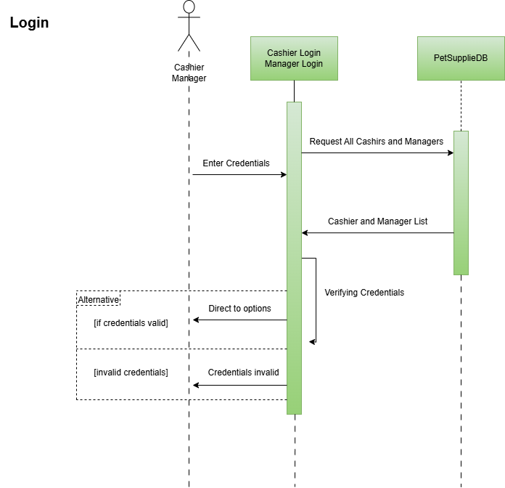
Figure 3/Login sequans diagram
- When a cashier or manager enter their username and password the system sends request to retrieve all stored user credentials.
- Once received list it checks the given credentials information. In this case they are valid the cashier and manager directed to cashier menu and manger menu. If the credentials are invalid the output page states an invalid username or password has been entered.
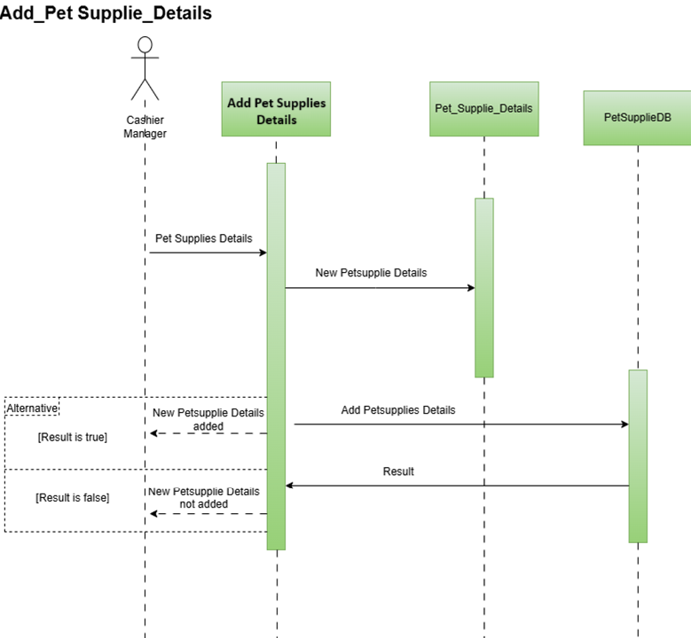
Figure 4/Add petsupplie detail sequans diagram
- Whenever a cashir or manager enters new pet supply details the main interface sends these details to Pet_Supplies. It then sends request to PetSupplieDB to store the new item.
- PetSupplieDB receives the details for Pet_Supplies and store in the Pet_Supplies_Detail txt file.
- After storing it send back a success or failure response.
- If succesfully added the interface displays message it means that new pet supply was succesfully added in the pet Pet_Supplies_Detail txt file . If not it show Error masage.

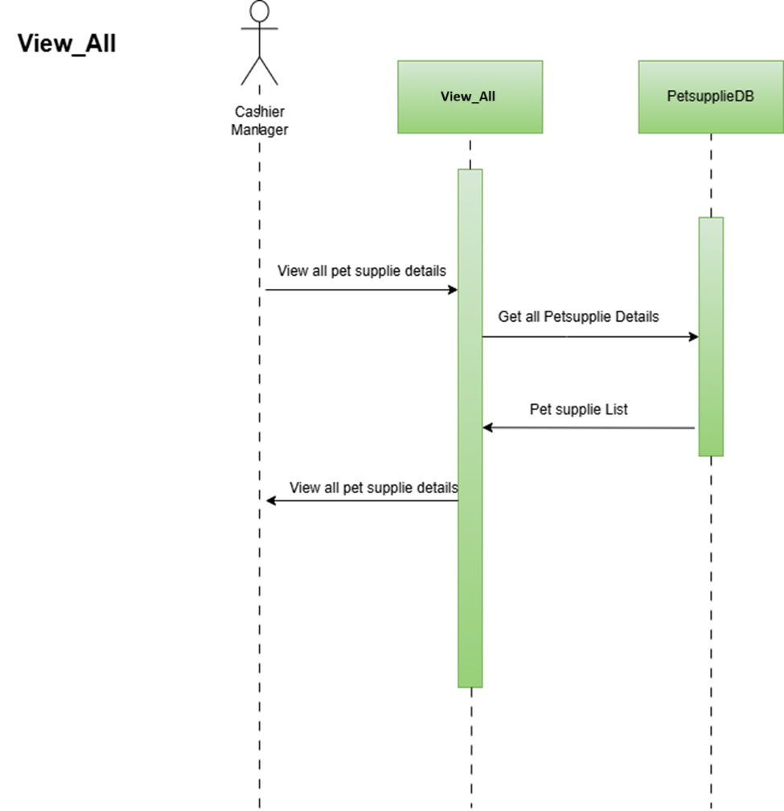
Figure 5/View all sequans diagram

- Whenever the cashier or manager click the submit button the interface send request to petsupplieDB to retrieve a list of all available pet supplies.
- After receiving the list it is displayed to the user through the interface.
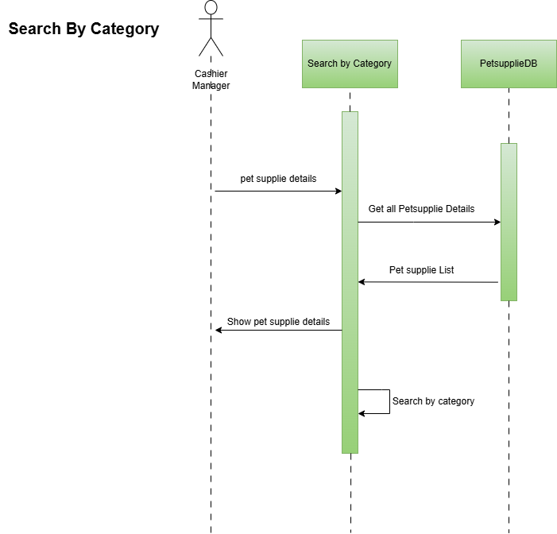
Figure 6/Search by category sequans diagram

- The cashier or manager select a category from the text area in the interface. The system then send a request to PetSupplieDB to search for matching pet supplies.
- PetSupplieDB retrieves pet supply details from Pet_Supplies_Details.txt that match the chosen category.
- If the matching the selected category are found the are displayed petsuppliedetails through the interface.

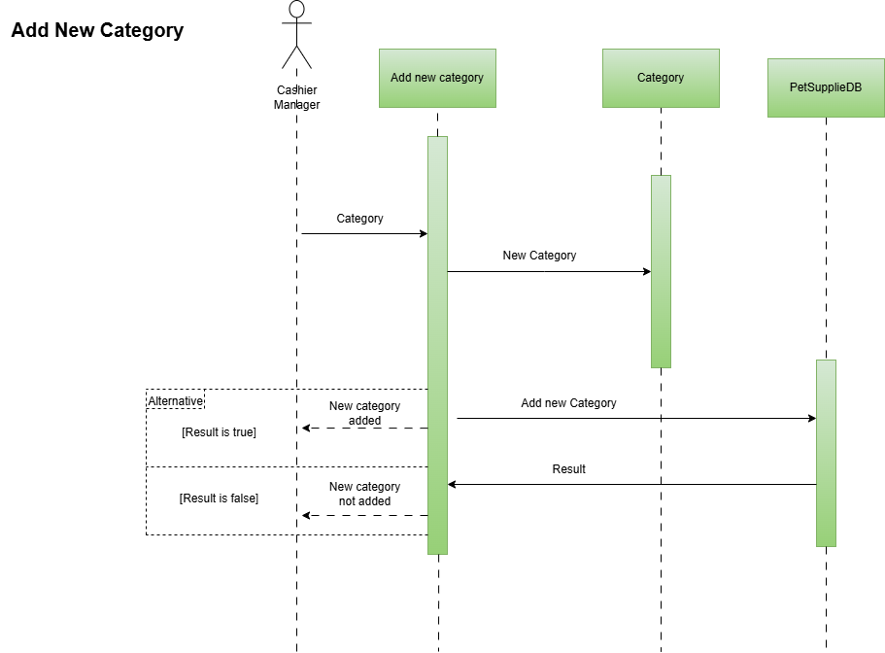

Figure 7/Add new category sequans diagram

- Whenever a cashier or manager enters new category details, the main interface sends these details to Add New Category. It then sends a request to petsupplieDB to store the new category.
- PetsupplieDB receives the details from Add New Category and stores them in the category.txt file.
- After storing, it sends back a success or failure response.
- If successfully added, the interface displays a message indicating that the new category was successfully added to the Category.txt file. If not, it shows an error message.
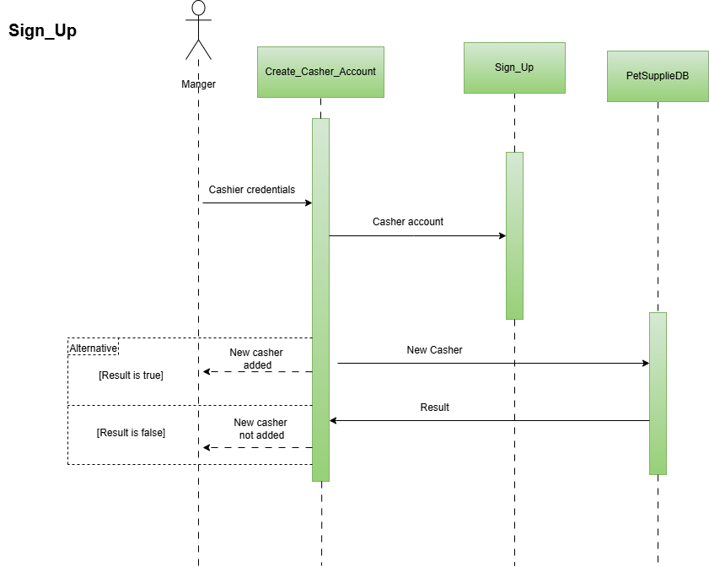
Figure 8/Sign up sequans diagram

- Whenever a manager enters new cashier details, the main interface sends these details to Sign_Up. It then sends a request to petsupplieDB to store the new cashier details.
- PetsupplieDB receives the details from Sign_Up and stores them in the CashierDtails.txt file.
- After storing, it sends back a success or failure response.
- If successfully added, the interface displays a message indicating that the new cashier details was successfully added to the CashierDtails.txt file. If not, it shows an error message.

(2)
The term Object-Oriented programing or java OOPs in programming concept means the language that use objects in programing they use object as fundamental entity to represent as what has to be done in the programmer code. Contemplated by the viewer or user, objects will executed actions which you assign to them.
Object-oriented programing as its name suggests tries to encapsulate ideas like inheritance, hiding, polymorphism etc. present in real world into programing. The primary goal of OOP is to encapsulate together data and the procedures that work on them in such a way that other programs cannot manipulate this data other than through this procedure. (geeksforgeeks, 2024)
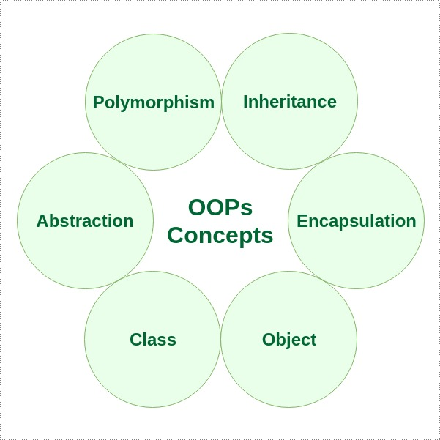

Figure 9/oop concepts

Object

In programing an object is an instance of a class that combine data and methods representing a real world concept within software. It encapsulates specific characteristic and behaviors, making it modular and reusable. Object are created for classes and help keep code organized by containing both attributes (data) and function (methods) in one unit, aligning program stricture with real world entities. This allow for better modularity, enabling different parts of a program to interact through distinct, self-contained objects.
Example
The variables psDB and ViewDtails are used to store reference to objects of types petSuppileDB and ViewDetailsByCategory, respectively. These references allow access to the methods in each class enabling interaction with those classes through these variables in other parts of the program.

Classes

In java a class is similar to a blueprint and describes functionality of an object through its properties (attributes) and its actions (methods). It serves as the foundation for creating objects with a specific set of characteristics and functionalities.
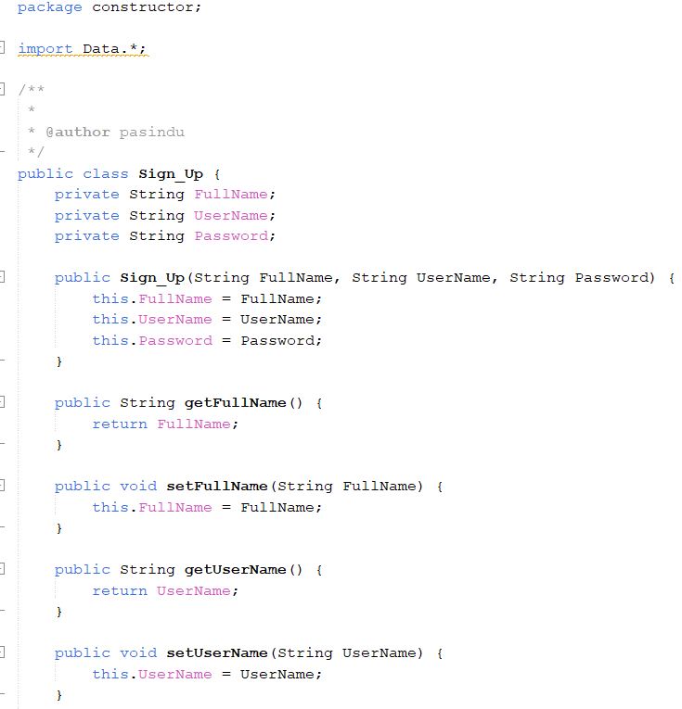
In the example above, the Sign_Up class serves as a template for creating user accounts in the system. Each user has attributes like FullName, UserName and Password ehich store their information. The class also provides getter and setter methods to retrieve and update these details ensuring consistent behavior for accessing and modifying user data.

Abstraction

Abstraction in java and in any object-oriented programming (OOP) paradigm is the practice of hiding the more complex implementation details and providing only the relevant features of a given object. It makes it possible for the programmers to be concerned about what the object does and how it does it. It reduces the amount of visible and usable code to the user, making it more comprehensible, easier to operate on with, and therefore-more efficient.
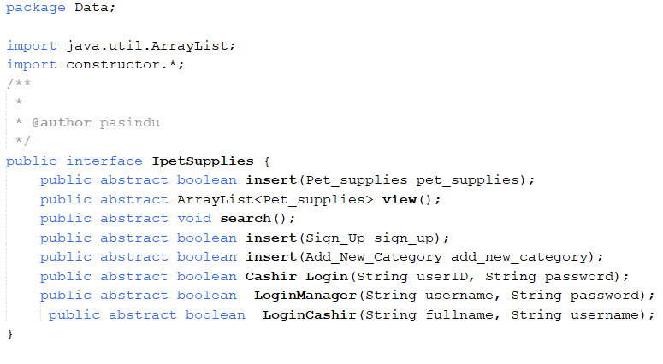

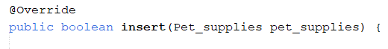

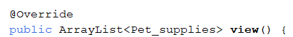
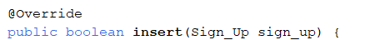

- The PetSuppleDB class implements the Ipetsupplies interface, where the methods defined in the interface area overridden.
- In the PetSupplieDB class, I take care of all the complex and detailed implementations of the methods like inserting pet supplies, viewing records, managing user logins, and others.
- This is a structured way, as I work with the lpetsupplies interface and do not have to bother about its implementation.
- In the end, this makes the code more organized and easy to maintain since the interface definitions are separated from the implementations.

Inheritance

In java, which following the object-oriented programing (OOP) model, another important feture is inheritance which enables a class to obtain the characteristics and behavior (in terms of fields and methods) of another class. It encourages reusability of code and establishes a relationship among classes lading to the concept of hierarchy where a child class (subclass) derives from a parent class (superclass).

In above example I use inheritance by having the cashier Add New Pet Supplies Details11 class extend Jframe. This allows it to inherit all the window properties and functionalities of Jframe such as displaying components and handling user actions, while adding cistom etures for cashier-specific tasks like entering and saving new pet supply details.

Encapsulation
In java, which following the object-oriented programing (OOP) model encapsulation is referred to the process of combining the data (attributes) and the procedures (functions) that work on that data, each inside class while preventing some parts of the class from being accessed. Encapsulation is useful as it guards the object’s state from any external changes as well as safe way of accessing the object’s information.
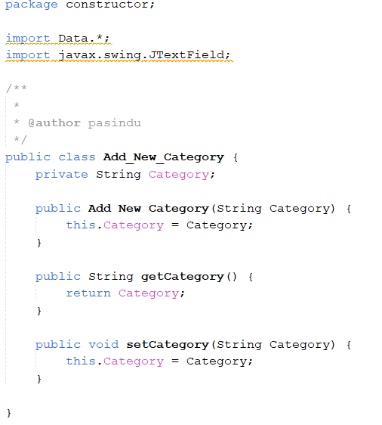

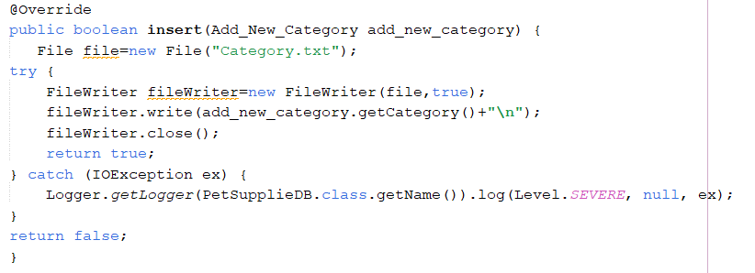

In this example the category attribute in the Add_New_Category class is declared as privet so it cannot be directly accessed or modified from outside the class. To interact with category, the class provides public methods like getCategory() and setCategory() which allow controlled access and modifications. This encapsulation ensures that only instances of Add_New_Category can handle the category attribute maintaining data security and integrity.

Polymorphism
In java, which following the object-oriented programing (OOP) model polymorphism means an object can take on many forms. It allows one action or method to be performed in several different manners depending on which object calls it. There are two main ways method overloading (which is a compile time polymorphism) and method overriding (which is a runtime polymorphism) means.

(4)User Manual for The Paws Shop Application

Introduction
- “The Paws Shop” is a pet supply management application designed to automate transaction processes, manage inventory and improve customer service for pet owners. The application has two user levels Cashier and Manager each with specific functionalities to simplify store operations. This guide will walk you through the features, setup and usage of the application.

- System Requirements
- Operating System:- Windows or macOS
- Net Beans IDE:- Version 8.2 or higher

- User Roles Functionalities
Cashier
- View all pet supply details
- Add new pet supply details
- Add new category
- Search for pet supplies based on category (e.g , pet toys , harness, cages, grooming products, collars, foods).
Manager
- The Manager has access to all Cashier functionalities and can also create new user account for Cashiers.
- File Structure
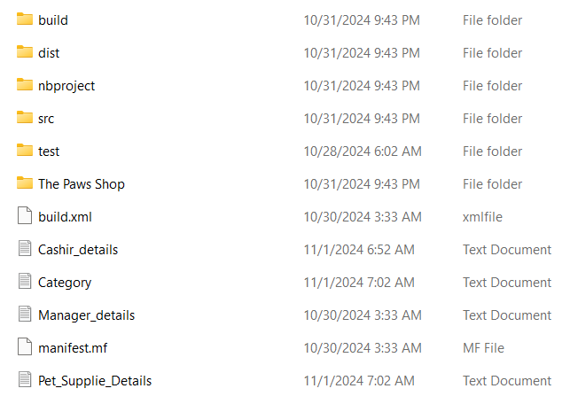
The application uses several text files to store data.
Store cashier usernames and password
Store details of each pet supply item
Store Manager Usernames and password

Store categories of pet supplies (e.g., toys, cages)

Using the Application

Login Method
Open the application. You will see an initial screen prompting you to choose your user role.
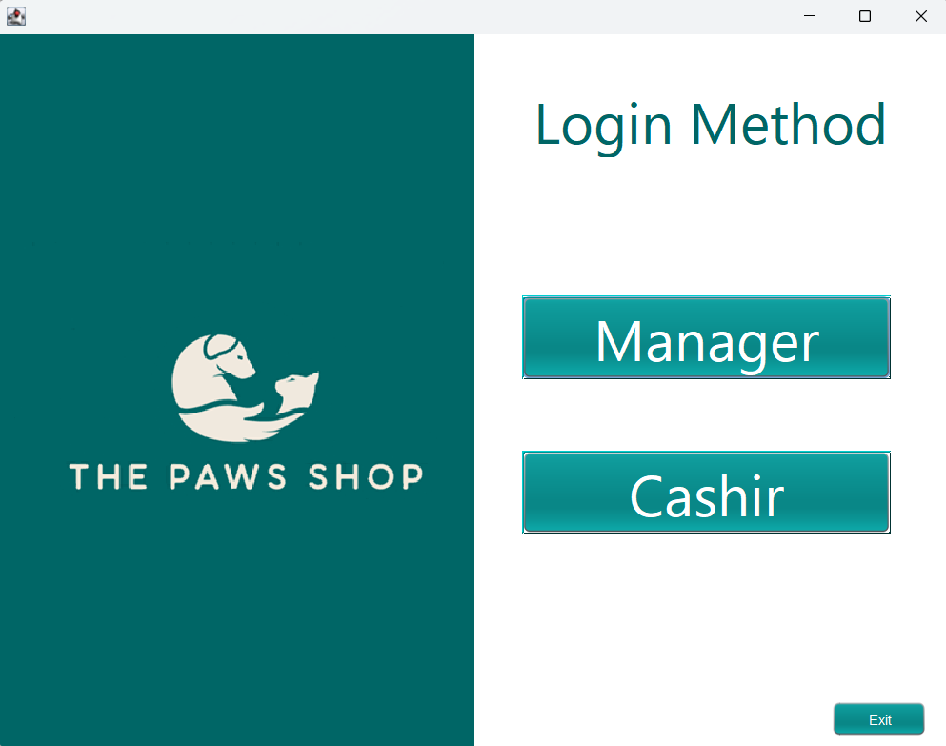

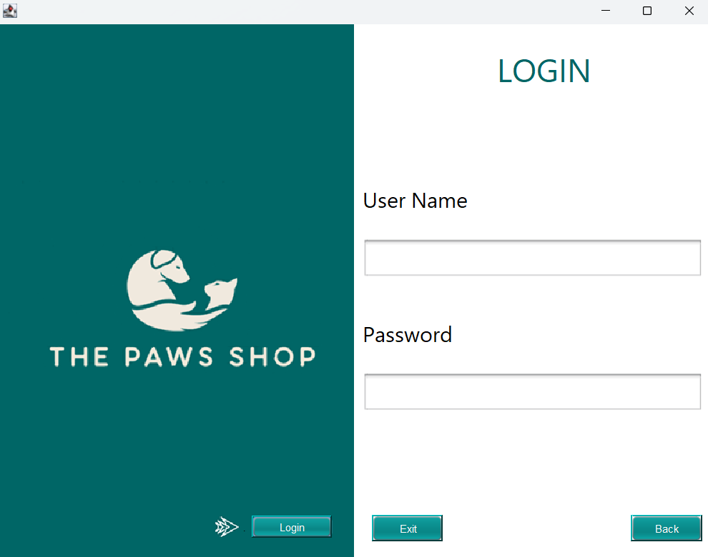
If you select Manager you will be directed to manager Login screen

Manager Username: - Kamal

Manager Password: - Kamal123

If the credentials do not match an “Invalid Manager Name or password” massage will appear allowing you to re-enter credentials.
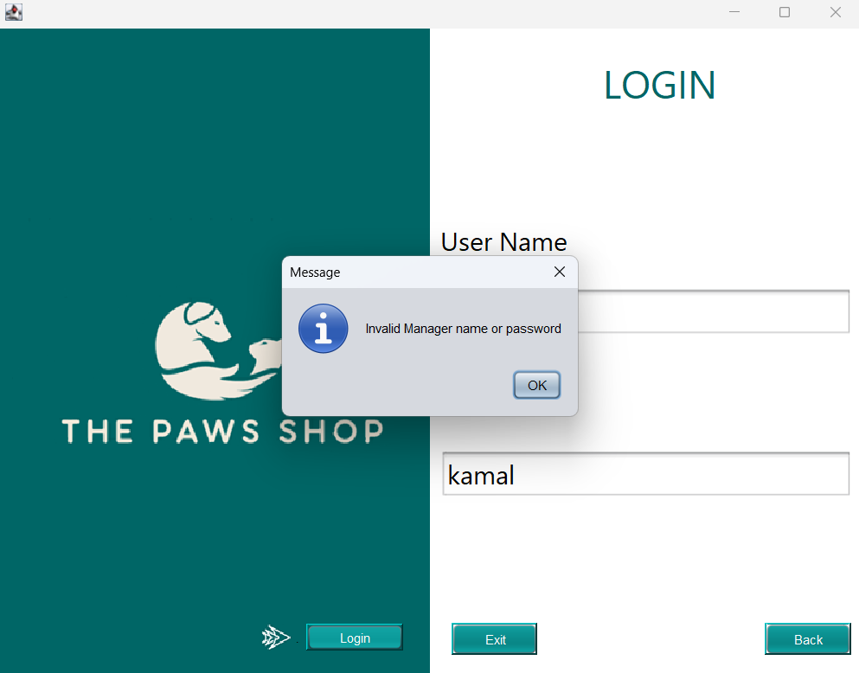


If you select Cashier you will be directed to cashier Login screen

Cashier Username: - Nimal

Cashier Password: - 123

If the credentials do not match an “Invalid Cashier Name or password” massage will appear allowing you to re-enter credentials.
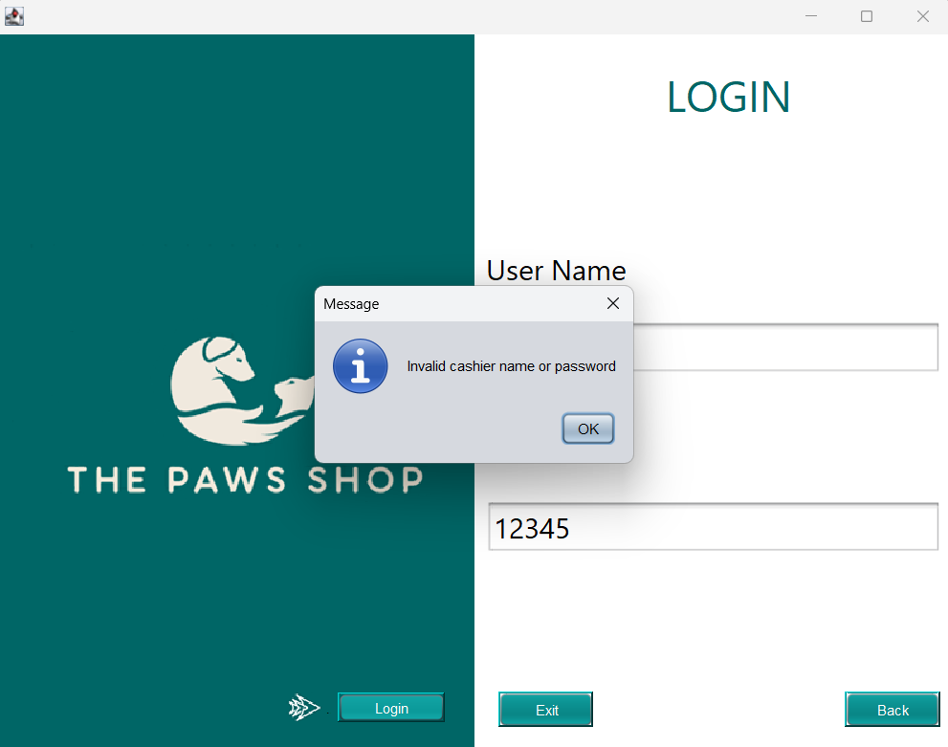

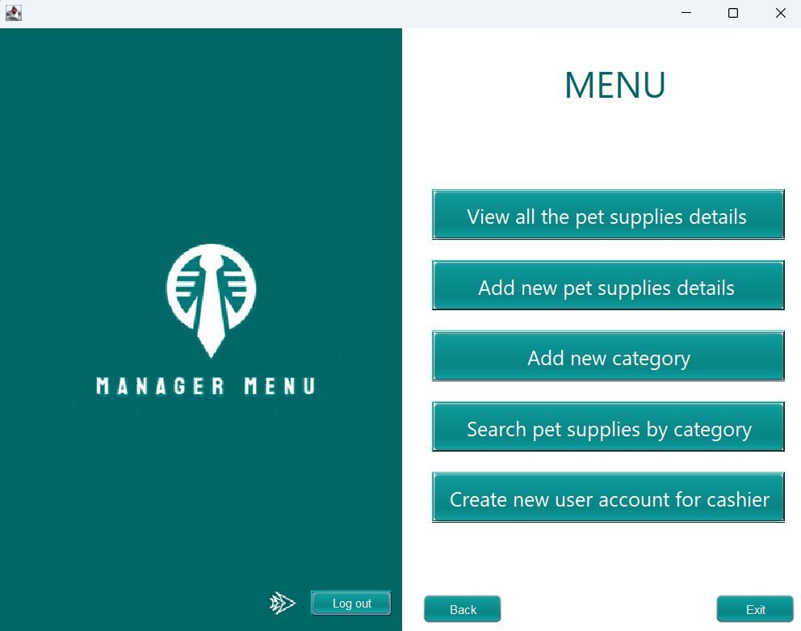
If the Manager’s credentials are match Manager are directed to Manager Menu

If the Casher’s credentials are match Manager are directed to Manager Menu
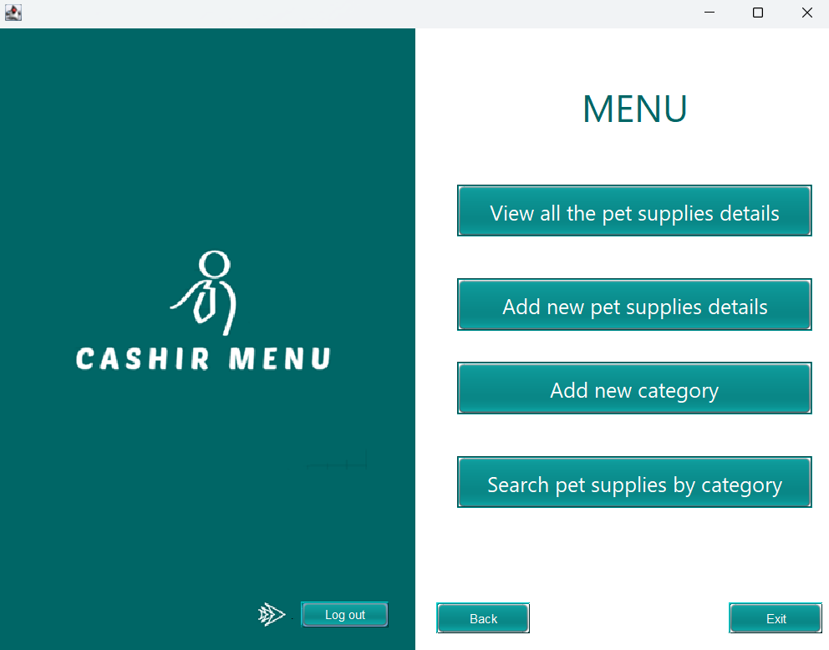

Manager and cashier Login credentials are verified against the information in Cashier_Deatils.txt or Manager_Details.txt files.

Functionalities

Cashier Functionalities
- View All Pet Supplies
- From the main menu select View All Pet Supplies Details
- The application will read data from Pet_supplie_Detail.txt and display a list of all available pet supplies, including categories, description, price etc.

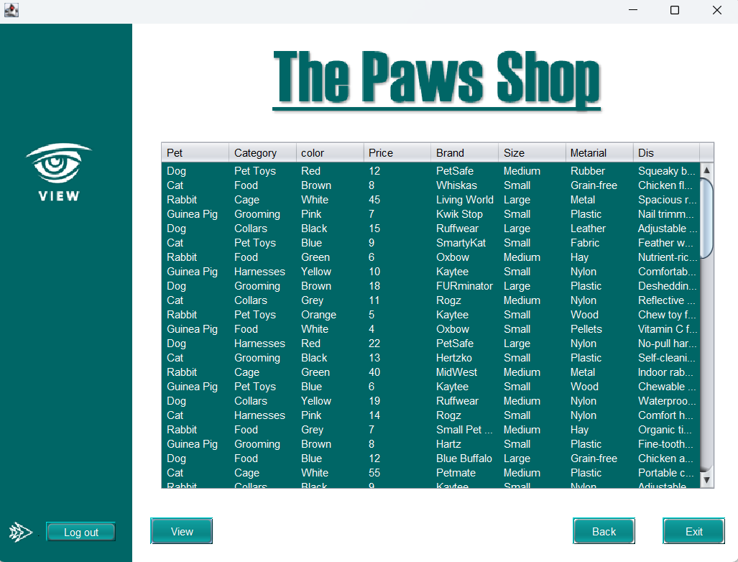

Add New Pet Supply
- From the main menu select Add New Pet Supplies Details
- Enter the Pet name, Category, Color, Price etc.
- Click submit to add the new item. The details will be saved to Pet_Supplies_Details.txt.
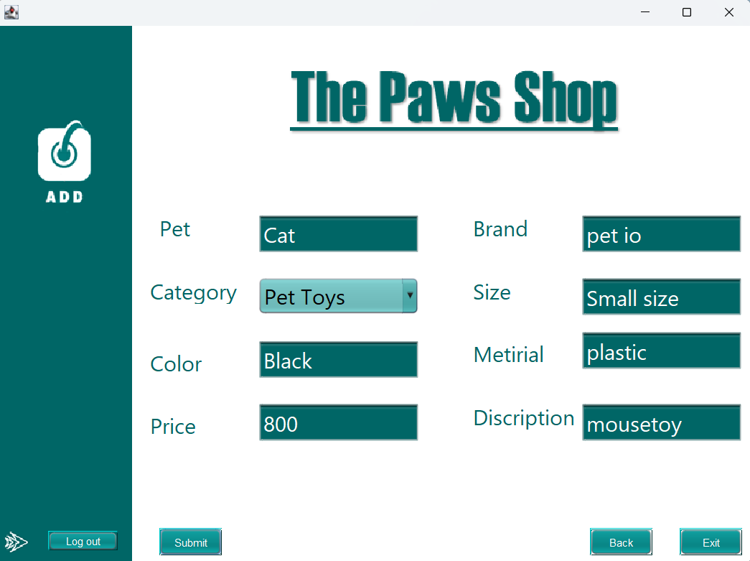

If details added successfully “Adding Successfully” massage will appear
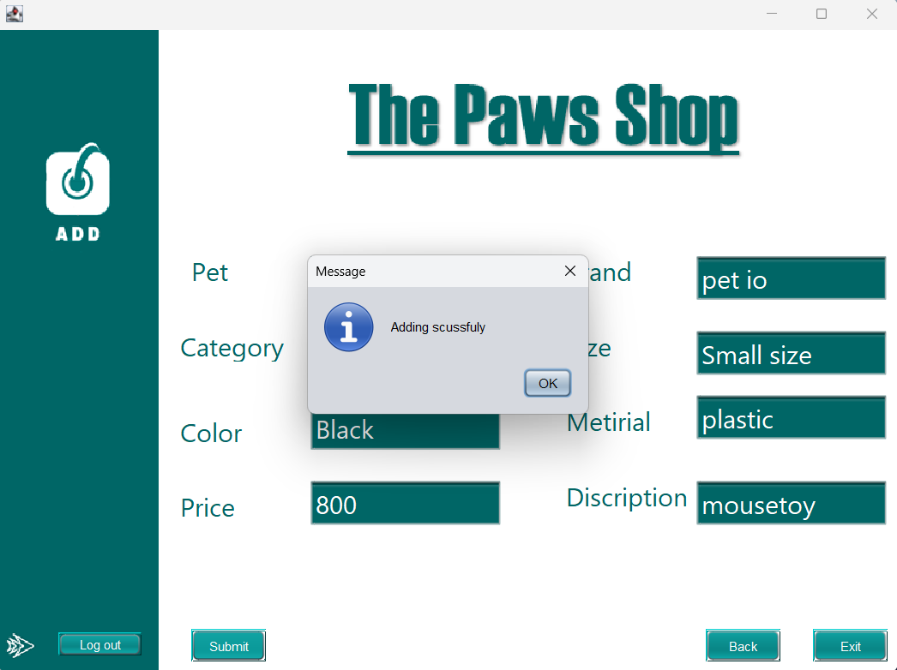

Add new category
- From the main menu select Add new category
- Enter category name.
- Click submit to add the new category. The details will be saved to Category.txt.
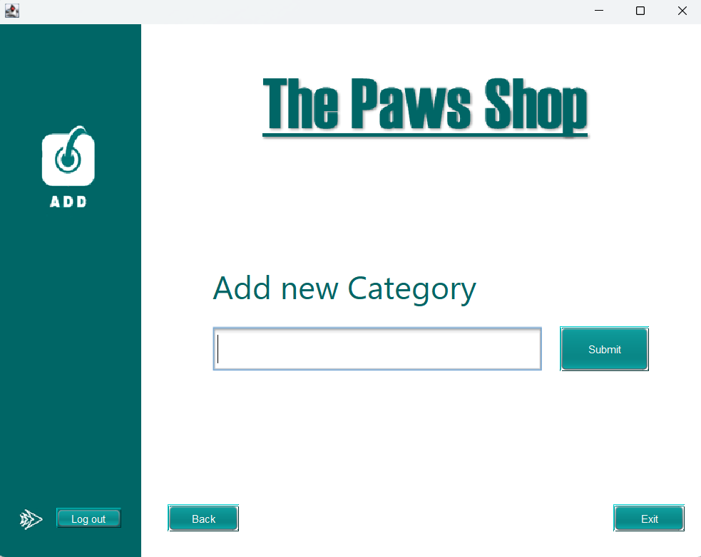

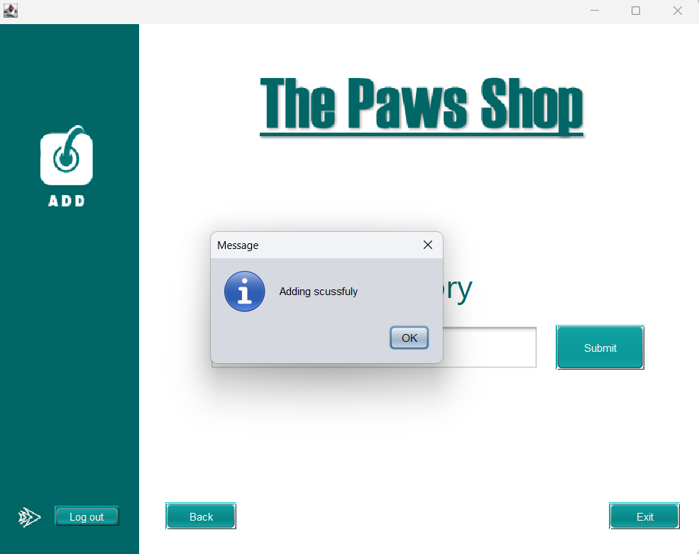
If details added successfully “Adding Successfully” massage will appear

Search pet supplies by category
- From the main menu select Search pet supplies by category
- Click on the category name you wont to search for from the text area.
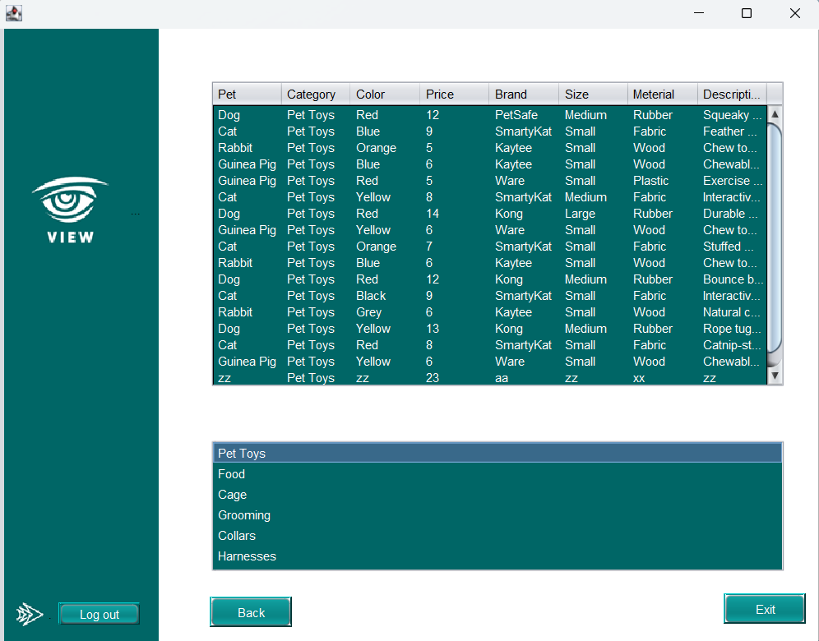

Manager Functionalities
- In addition to the cashier functionalities the Manager can also

Creating new user account for cashier
- From the manager menu select Creating new account for cashier
- Enter new cashier’s Full name, Usernames and Password.
- Click Submit to add new cashier. The credentials will be saved to Cashir_Detail.txt.
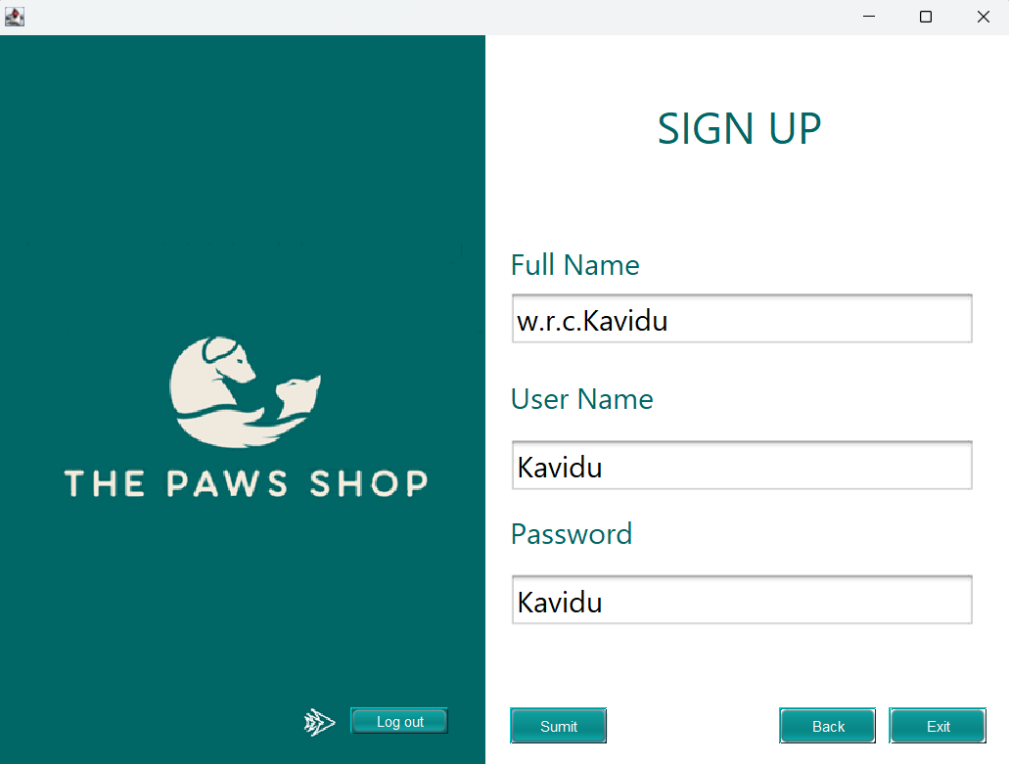

If details added successfully “Adding Successfully” massage will appear
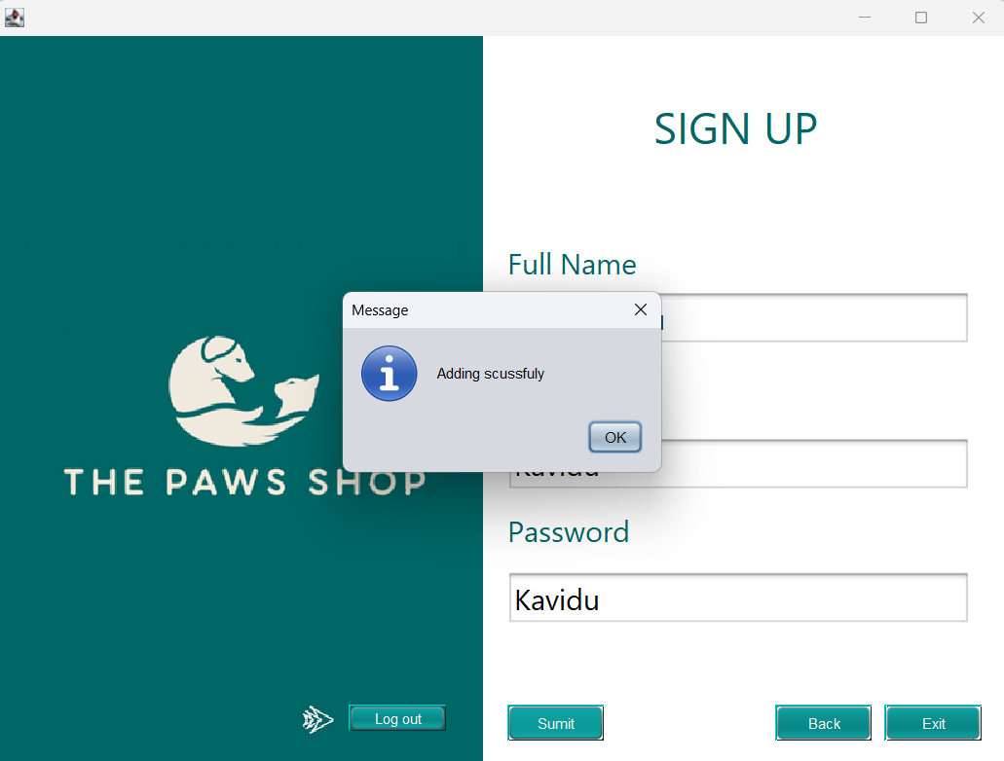

Error Handling and Troubleshooting
- Invalid Login: - If you receive an Error message recheck your username and password or contact your manager if you forget your credentials.
- File not found: - Ensure that all required file(Cashier_Detail.txt, Manager_Detail.txt, Category.txt, Pet_Supplie.txt) are in the correct directory. The application will not work if these files are missing.
- File format Error:- Ensure data is saved in the correct format in each file. Improper formatting may prevent the application from reading or writing data correctly.

References
geeksforgeeks. (2024, october 4). Retrieved from geeksforgeeks: https://www.geeksforgeeks.org/object-oriented-programming-oops-concept-in-java/

